Raymond Delgado

CIS 5270

Professor Balan

Python Lab 06

Q1) How many keywords are there in Python version 3.0 (or above)?

A1) There is a total of 33 keywords that are in Python version 3.0.

Q2) Name at least 5 of the keywords that python version 3.0 (or above)?

A2)

1)Import: Allows us to use external module for our code. These modules will add more functionality to our program. Example:

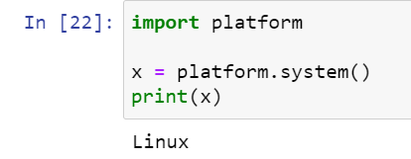

2) While: The loop will continue while a certain requirement is true. Enables the use of while loop. Example:

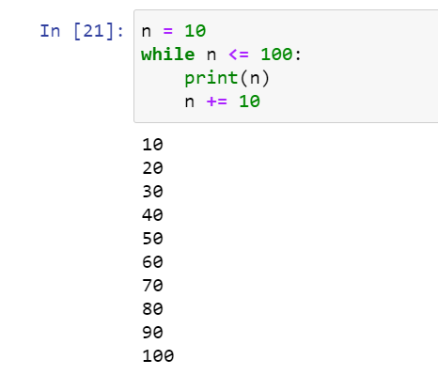

3) Try: Allows us check if a certain block of code for errors. Allows to write to custom errors and exceptions messages. Example:

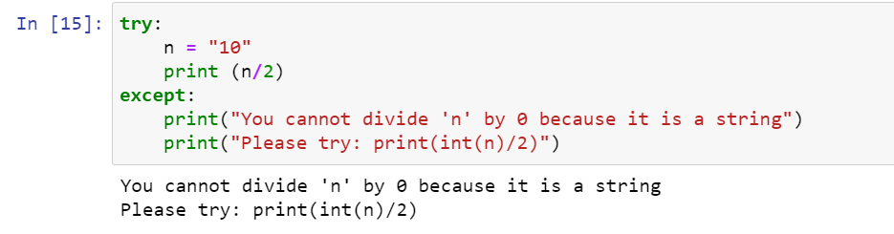

4) Break: Allows the program to exit a loop early. Example:

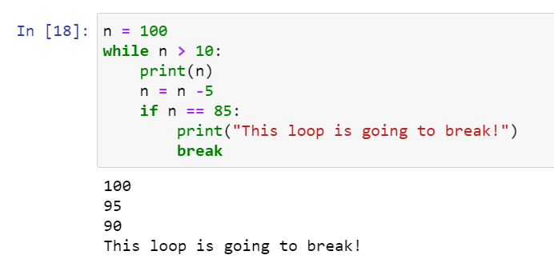

5) Return: Used inside a function/method to send the results back to the caller.

Example:

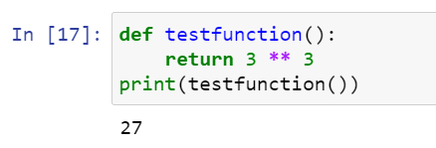

Q3) How do you add “comments” in a Python code?

A3) You can add single line comments by using #

Example:



Q4) Explain the flowing in your own words:



Firstly, this whole block of code is an example of a for loop. The most common reason to use a for loop is to go through a list of items. In this case, the list is the variable called number. N is the variable that is used to index through out the list. Let us assume that values for number is [1,2,3]. This means that this for loop will run 3 times and print each value individually. The output should be something like this:

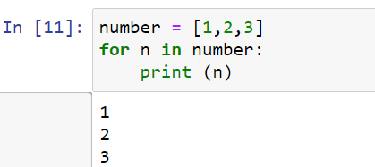

Q5) Can we use try/except in Python? If so, what is its purpose? Show an example.

A5) We can use try/except in Python. The try statement is test our code for any errors and/or exceptions. The except statement allows us to create unique error messages for our code. This will allow the developer to write error messages that are more informative and easier to understand. Here is an example of try/except statement:



In this example I used both try and except statement to create a new error message that clearly define the issue and provides a way to resolve this issue.